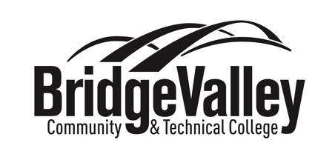
BridgeValley Collegiate Recovery Program Scholarship
Application 2023-2024

The Collegiate Recovery Program (CRP) provides a safe, nurturing, and affirming environment where students in recovery can receive the assistance and support they need to achieve academic success and personal goals while in college. The CRP facilitates a supportive, stigma-free community of students in recovery through individual, academic, social, and recovery supports.

The BridgeValley Scholarship opportunity is grant funded for the 2023-2024 academic year.

ELIGIBILITY CRITERIA: The applicant must:
- Be actively pursuing recovery from substance use disorder, alcoholism, eating disorder, mental health challenges.
- Actively participate in the BridgeValley Collegiate Recovery Program for the 2023-2024 school year, be a BridgeValley Student and (ex. Attend CRP events, engage in peer mentoring, be involved in community service projects and outreach)
- Demonstrate successful academic performance. Students on academic probation are not eligible.

APPLICATION REQUIREMENTS
Students seeking a BridgeValley Collegiate Recovery Scholarship must:
- Prepare a 500-word statement (Typed) describing how you have overcome challenges related to your drug addiction and/or alcoholism.
- Provide one letter of recommendation from an individual who can comment on your commitment to your recovery.
- Complete the General Information Section (below).
- Forward these documents via e-mail to recoveryservices@bridgevalley.edu by June 30, 2023 Incomplete applications will not be considered.

ADDITIONAL CRP PARTICIPATION SCHOLARSHIPS FOR STUDENTS WHO HAVE RECEIVED A CRP
SCHOLARSHIP PREVIOUSLY
- Prepare a 500-word statement (Typed), summarizing your involvement in the CRP last semester and describing what the CRP at BridgeValley means to you.
- Be actively involved in the CRP activities throughout the semester. (ex. Attend CRP events, peer mentoring, community service and outreach)
- 2.5 Grade Point Average.
- Forward these documents via e-mail to recoveryservices@bridegevalley.edu by June 30, 2023. Incomplete applications will not be considered.

For more information contact recoveryservices@bridgevalley.edu
BridgeValley Collegiate Recovery Program Scholarship
Application 2023-2024

GENERAL INFORMATION

Name: ________________________________________ Preferred Name: _________________________

BridgeValley E-Mail: ____________________________________ (Communication with you will be done by e-mail)

Permanent Address:
_________________________________________________________________________________

City: ______________________ State __________________________ Zip: _____________________________

Telephone: _____________________________________ Texting OK? Yes or No

B Number (student ID number): ___________ Expected Graduation Date: ______________

Major: _____________________________________________

Current Status: Freshman Sophomore Junior Senior

